Created by Lionel Weber, the 7 December 2010
Modified by Lionel Weber, the 03 December 2012

Wigii how to install on a server

Requirements
- php 5.3 or above
- mysql 5
- php required extensions:
- curl
- php_mysql
- php_mbstring
- php_openssl
- php settings
- short open tag
- apache module
- rewrite module
- hard drive space:
- 150Mb for source code
- XGb for storage files. I suggest:
- 10Gb at least if storing basic office files
- 30Gb for a multi type of files usage with a limit of 50Mb per file.
- More if the limit per file is larger and multimedia files would be uploaded.
- PhpMyAdmin access to the mysql database makes life easier

Apache / Mysql configuration:
In the php.ini configuration I would advise to make the max_execution_time at 2-3 minutes. This is not mandatory, meaning 10s is enough, but if you want to be able to do some administration calculation without changing this configuration, it could be great to increase the max execution time.
The post_max_size, upload_max_filesize (php.ini) and the max_allowed_packet (my.ini) will determine the maximum size of the files you allow to upload in one request. I suggest you increase those parameter to 300M minimum. I suggest that the max_allowed_packet is 1.5 the size of the post_max_size (this depends also if you want that the files are stored in the DB or on a file structure)
You need to add in the my.ini lower_case_table_names=2 as well. Like this there will be no export/import issues for mysql database.
The memory_limit needs to be minimum 64M to be able to manage photos. However depending of the load on your server you could increase it to 128M?
The session.gc_maxlifetime is the time of a session. I would suggest to increase it at 2h. I think it is good that people are not stressed during using wigii, especially that in the office wigii could be opened all day on every computer, because everyone often need a small info on it. So it is worthy if you don’t need to login again. However, if you could not increase this, there is an auto-login feature which helps for relogin if the session died.
The date.timezone must be defined to "Europe/Paris".
(for now the export to excel is not done for 2007 version. So no need to wonder of that).
If the export to excel function is available and setted for excel 2007, PHPExcel lib will use the root /tmp/ directory. In that case be sure you allow the script to access this folder. The Safe_Mode of php need to be disabled as well.

Create the Database
Create a MySql user:
- Click → MySQL → MySQL console
- No password for the moment : hit ENTER
- Add a password to the user « root » :
SET PASSWORD = PASSWORD('biscuit');
- Create the wigii user (this needs to match the content of your start.php file):
GRANT ALL PRIVILEGES ON *.* TO 'wigii'@'localhost' IDENTIFIED BY 'mywigii-pass' WITH GRANT OPTION;
- quit
exit
- Note: to connect again to mysql:
mysql –u root –p
enter the password you’ve defined.
Configure phpMyAdmin to use the root password:
- Open the file « config.inc.php » in the folder « phpmyadmin » of WAMP/apps/
- Add the password root in this file
In phpMyAdmin create a new Database with collation to: utf8_unicode_ci
Import “Readme/Wigii4 table structure.sql” to create all the tables and the index.
Create your user in the database linked to a SuperAdmin role.
INSERT INTO `Users` SET
`username` = "Example",
`wigiiNamespace` = NULL,
`password` = md5("myPass"),
`passwordLength` = 6,
`canModifyOwnPassword` = TRUE,
`authenticationMethod` = "usual",
`description` = CONCAT("First user. Created on ",SYSDATE()),
`sys_date` = UNIX_TIMESTAMP(),
`sys_user` = 1,
`isRole` = FALSE
;

INSERT INTO `Users` SET
`username` = "SuperAdmin",
`wigiiNamespace` = NULL,
`password` = md5(CONCAT("SuperAdmin",UNIX_TIMESTAMP())),
`passwordLength` = 0,
`canModifyOwnPassword` = TRUE,
`authenticationMethod` = "usual",
`description` = CONCAT("Main SuperAdmin role. Created on ",SYSDATE()),
`wigiiNamespaceCreator` = TRUE,
`moduleEditor` = TRUE,
`readAllUsersInWigiiNamespace` = TRUE,
`adminCreator` = TRUE,
`userCreator` = TRUE,
`moduleAccess` = "Admin;Contacts;Events;Filemanager;Projects",
`readAllGroupsInWigiiNamespace` = "Contacts;Events;Filemanager;Projects",
`rootGroupCreator` = "Contacts;Events;Filemanager;Projects",
`groupCreator` = "Contacts;Events;Filemanager;Projects",
`sys_date` = UNIX_TIMESTAMP(),
`sys_user` = 1,
`isRole` = TRUE
;

INSERT INTO `Users_Users`
(`id_relation_user` ,`id_user_owner` ,`id_user` ,`isOwner` ,`hasRole`)
VALUES
(NULL , '1', '2', NULL , '1')
;
This script created a user: “Example” with the password “myPass” + a role “SuperAdmin” with all rights to manage the database. The user “Example” has been granted the use of the role “SuperAdmin”.

Check the folder/file structure
The file structure of a wigii instance can be redefined in the index.php file. However here is a standard advised file structure to run a wigii instance. The red folders needs to be created. Some of the ClientFolder already exist with the Example client name. If you want to define the Client name yourself rename each ClientFolder to MyClientName…
- data
  - wigiiSystem
    - configs
      - ClientFolder (777)
      - template
Used to dump the debug and log execution when enabled.
    - core…
    - tempUploadedFiles (777)
- log (777)
- tmp (777)
- users
Used to store the session files.
  - ClientFolder
    - data
      - uploadedFiles (777)
Used to store all the uploaded files
- www
  - assets
    - css…
    - js…
  - images…
  - temporary_unzipForViewing (777)
  - ClientFolder… (777)
    - imageForHtmlEditor (777)
Used to store images or files uploaded through the html CKEditor.

This file structure can be slightly changed. All this structure should match what is defined in the index.php file.

Edit the main system config files

.htaccess
The Wigii system use url rewrite rules. You need in your www folder a .htaccess file with this content:
Check that ../tmp/ refers to a valid folder on which 777 is set. If you experience session problem you can delete this line. This will take the basic place for sessions.

php_value session.save_path '../tmp/'
php_flag display_errors on
php_flag display_startup_errors on
php_flag html_errors on
php_flag log_errors off
php_flag track_errors on
php_value error_reporting 30711

AddType application/x-httpd-php .html
Options +FollowSymlinks

RewriteEngine On
RewriteCond %{SCRIPT_FILENAME} !-f
RewriteCond %{SCRIPT_FILENAME} !-d
RewriteRule ^modif/(.*)$ %{HTTP_REFERER}indexModif.php?url=$1 [L]

RewriteCond %{SCRIPT_FILENAME} !-f
RewriteCond %{SCRIPT_FILENAME} !-d
RewriteRule ^(.*)$ %{HTTP_REFERER}index.php?url=$1 [L]

index.php
The rewrite rules of the .htaccess make that any request on your wigii url are redirected on index.php with the url parameter containing the text of the initial url. → this implicates that any request goes through the index.php file.

Adapt your index.php file based on readme/new example index.php. Usually only the first part of the php file needs to be updated. Here is the main part you should check:

//CLIENT Selector for LOCALHOST
Define the url (or a list of url) you use to access your wigii system. Foreach url you can define a client_name. The CLIENT_NAME is then used for finding the location of any Client settings.
switch($_SERVER['HTTP_HOST']){
case "localhost":
case "wigii.YOURWEBSITE.org":
define ("CLIENT_NAME", "YOURCLIENTNAME" );
break;
default:
echo "wigii system, no client selected";
return;
break;
}

The following needs to match your files structure.
/**
* main paths
*/
define("CLIENT_WEB_PATH", CLIENT_NAME."/" );
define("CLIENT_WEB_URL", CLIENT_WEB_PATH );
define("TEMPORARYUPLOADEDFILE_path", "tempUploadedFiles/");
define("TEMPORARYUNZIPFORVIEWINGFILE_path", "temporary_unzipForViewing/");
define("FILES_PATH", "../users/" . CLIENT_NAME . "/data/uploadedFiles/");

define("LOG_PATH", "../log/"); //stores the log when sys console is enabled
define("TMP_PATH", "../tmp/"); //stores the session files, this is defined in the .htaccess

define("wigiiSystem_PATH", "../data/wigiiSystem/");
define("CORE_PATH", wigiiSystem_PATH . "core/");
define("IMPL_PATH", CORE_PATH . "_webImplExecutor/");
define("TEMPLATE_PATH", IMPL_PATH . "templates/");
define("DATATYPE_PATH", CORE_PATH . "datatype/");
define("LANG_FOLDER", CORE_PATH . "langs/");
define("CLIENT_CONFIG_PATH", wigiiSystem_PATH . "configs/" . CLIENT_NAME . "/");

You can enable or not the statistics services. By enabling a statistic service, each action in the wigii system linked to the service will be stored into a statistic table. Those tables have not a cleanup process. You need to clean those tables manually. No tool is provided in wigii to do statistics.
/**
* configuration part
*/
define("GLOBAL_STATISTIC_ENABLED", true);
define("ELEMENT_STATISTIC_ENABLED", false);
define("FILE_STATISTIC_ENABLED", false);
define("TEMPORARYUPLOADEDFILE_lifetime", 60 * 60 * 24); //number of second a file remains in the temp folder
define("TEMPORARYUNZIPFORVIEWINGFILE_lifetime", 60 * 60 * 12); //number of second a file remains in the temp folder for viewing

data/wigiiSystem/configs/ClientFolder/
This folder contains all the settings of the client. Note that in the index.php you can define a clientName different based on the url used to access the wigii system. That means you can potentially use a different config folder for each client (→ different settings per url).

A Client config folder needs to have:
- config.php
  - this file contains settings for sending emails
  - define the default language, and which language are visible (max 10 language, currently only English and French are available)
  - define limitation on group, user or password values
- config.xml
  - define the website title
  - the top bar color
  - and a bunch of other things
- start.php
  - define the DB settings
  - starts the Wigii implementation. You could again do a switch to start a different implementation based on the CLIENT_NAME.
- dico_ClientName.txt
  - this can remains empty.
  - This folder could overwrite any entry in the main core/lang/dico.txt file.
- Admin_config.xml
  - You can define a list of blacklisted user or authorized user.
  - By default I suggest to keep this empty. Documentation can be find on that in the Configuration reference guide.
- One …_config.xml file per tab you want in your wigii system. So usually:
  - Contacts_config.xml
  - Filemanager_config.xml
  - Events_config.xml
  - Each of these file contains the configuration for the tab. More specific configuration can be added per namespace, per group, per user. Check the configuration manual to find out more about the hierarchy.

www/ClientFolder/
The client folder in the www is for images, client javascripts, or client css definition. This folder needs to have:
- banner.php
  - this file can remain empty. You can use this file to add a logo in the top bar.
- CKTemplates.js
  - This file contains the template available in the template menu of the CKEditor (html editor) wigii use in textareas. You can redefine other templates based on the "standard" example.
- CLIENT_NAME.js
  - This file can remain empty. You can add some specific client js code if needed.
- CLIENT_NAME.css
  - This file can remain empty. You can redefine per client some specific css if needed.
- /imageForHtmlEditor
  - This folder will contain all files that users decide to upload with the CKEditor plugin. Those files have coded urls. That means if someone knows the url to the file he can access it from outside, but this url cannot be predicted.

data/wigiiSystem/core/_webImplExecutor/autoload.php
If you experiment some Fatal error: Class '….' not found in …. That probably means you have an error in your file structure. Be aware that the autoload.php file contains all the paths to access the php Object class file.

Run the system
If you have installed the system on localhost with wamp for i.e., add an alias to the apache server:
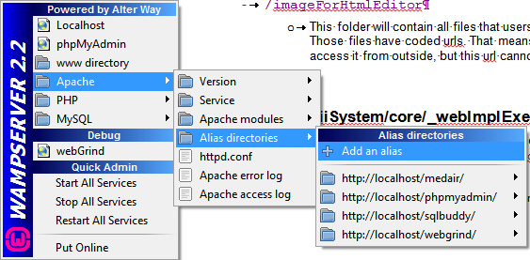

And add the alias : example
And define the patch to your local www folder.
Then open a browser and type: http://localhost/example/
You should see a screen like:
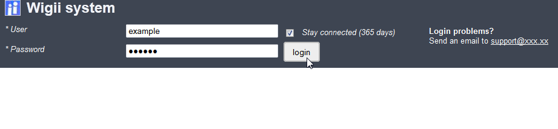
Login with: example and password: myPass
When you try to login if you get a mysql warning or error that means you have a problem in the settings of your database (look in start.php).

Trouble shoots:
- Ensure you have defined the password of the user with the md5 function
- Ensure your browser has javascript enabled
- Ensure your .htaccess file rewrite correctly the urls (on localhost your url will be as http://localhost/example/, in your .htacess your need to have the rules
  - RewriteCond %{REQUEST_URI} ^.*example/.*$
  - RewriteRule ^(.*)$ /example/index.php?url=$1 [L]
  - Those two lines will rewrite any url localhost/example/… to locatlhost/example/index.php?url=…
- Ensure you are on Wampserver 2.2e running php 5.3.13, httpd 2.2.22 and mysql 5.5.24
- If you are unable to access http://127.0.0.1/ using the http://localhost/ url
  - Open httpd.conf file
  - Edit by adding the two last line to the code where you find the 127.0.0.1 address:
Order Deny,Allow
Deny from all
Allow from 127.0.0.1
Allow from localhost
Allow from ::1
- Ensure short_open_tag setting is enabled in php

Create your first namespace
Wigii works with namespace. A namespace is an area in the system. You need to have at least one namespace to start using the system. A namespace contains users, roles, folders, access rights and datas. Everything is meant to stay within the namespace. Creating another namespace is as if you want to create another wigii system in the same wigii system. Only the superadmin role can have an overview of all namespace. However, you need to know that an administrator of a namespace (NAdmin) is able to grant access to his namespace to users defined in other namespace. This allows users accessing multiple namespace if some Nadmin “invited” them.
Let’s create our first namespace as an example:
- Open admin console
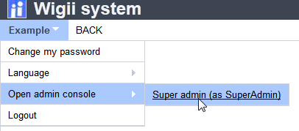
- Click on General configuration
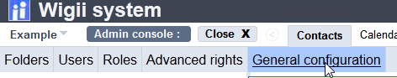
This administrator sub screen contains a bunch of useful tools for superadmin:
  - You can edit here all configuration files directly on-line
  - You can create new namespaces.
- Click on “Create a namespace”. This example shows how to create a namespace called KPI. This KPI namespace will use the four base tabs : Contacts, Files, Calendar and Projects.
I’ve added a kpi-support email address that will be added by the system for the feedback buttons. Users of KPI namespace will contact by default the kpi-support.
I’ve linked this new namespace to my first user “Example”.
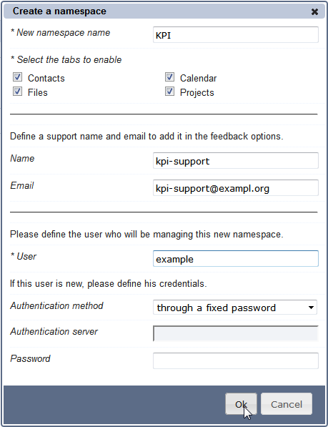
- 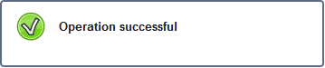
- I can now close the admin console and access to my first namespace :
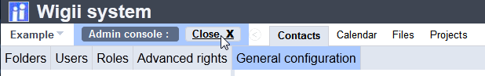
- 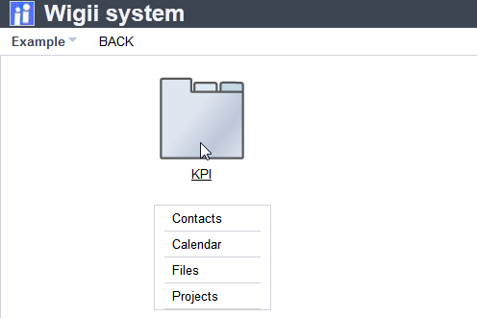
As my user is “Example” and do not belong to the KPI namespace I see the KPI folder as this screen shot. If I change the namespace of my “Example” user by Opening admin console as SuperAdmin, click on subscreen users, select the user “Example”, click Edit, define the Namespace to: KPI, click Ok, click close admin console, logout, and relogin as “Example” / “myPass”, I would see the screen as:
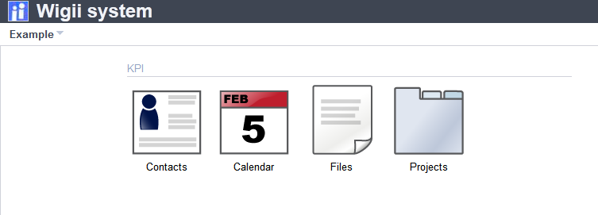
- In my user menu, I have now to ways to open the admin console.
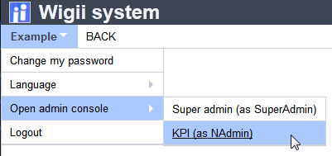
By opening the KPI admin console I will be able to manage only the KPI folders, users, roles, etc.

